Is Volodymyr Zelensky a Comedian or a Strong Leader?

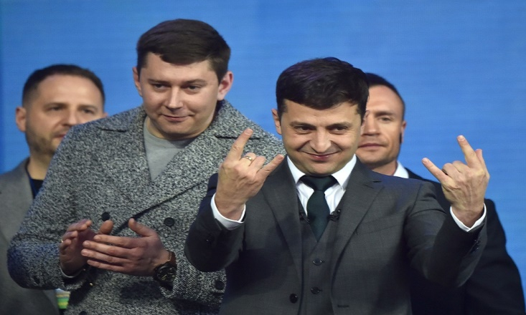

*Source -*[*https://cdn.cnn.com/cnnnext/dam/assets/190419195745-volodymyr-zelensky-ukraine-debate.jpg*](https://cdn.cnn.com/cnnnext/dam/assets/190419195745-volodymyr-zelensky-ukraine-debate.jpg)

The whole globe is watching out for the dispute between Russia and Ukraine. While NATO is reluctant to face Putin, the Ukrainian public, headed by Volodymyr Zelensky, is battling for their fundamental privileges and freedoms. This is the Comedian and entertainer who was chosen as President of Ukraine. He was named a Comedian and an inspired ruler. He was offered the opportunity to escape from Ukraine, yet he decided to remain. While the Global heads of the world and NATO hiding behind the rocks, he is responsible for a country that isn't terrified to go up against Putin.

# What was his Childhood Like?

 Kryvyi Rih, a huge city in focal Ukraine, is where Volodymyr Zelensky was born on January 25, 1978. Volodymyr's family was knowledgeable and socially complex. His dad was a professor, and his mom pledged her whole life to raise her son. Zelensky lived for four years in the Mongolian city before the beginning of the elementary school of Erdenet. When the family got back to Ukraine, they dwelled in an area known as "AntHill" by the people of Kryvyi Rih. Likewise, he took an interest in Basketball and weightlifting, and he appreciated Ball dancing for a period. He then figured out how to play the piano and guitar, which he utilized in school groups and dramatic plays. He was always appreciated performing in front of an audience. Volodymyr then signed up for the Kryvyi Rih State University of Economics and Technology, where he procured a Law degree.

## The Time of His Acting Life

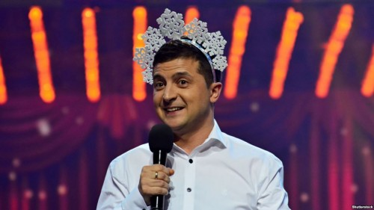

*Source -*[*https://gdb.rferl.org/675DC09E-FDCF-4B44-BAF0-D3A0D9FB2277_w408_r1_s.jpg*](https://gdb.rferl.org/675DC09E-FDCF-4B44-BAF0-D3A0D9FB2277_w408_r1_s.jpg)

At the age of 17, Zelensky joined the local KVN team. In the CIS countries, this is a popular comedy competition where teams from different countries take part. Players prepare several humorous performances on given topics and show them to the jury. Zelensky was noticed and invited to the Ukrainian team Zaporizhzhia-Kryvyi Rih, which played in the Major League and won in 1997. Zelensky did not appear in the main cast, but instead assisted with the scenery and taught the companions how to dance, eventually landing a role.

Afterward, he and his companions made their own studio called 95 Quarter. He never restricted himself as an entertainer yet, in addition, took up the job of the author. Notwithstanding, 95 Quarter was performing great, yet KVN needed Zelensky to remain with them without his group. Zelensky denied the deal and stuck with his companions and 95 Quarter. What's more, the rest of the studio is history.

## What was Volodymyr Zelensky's Next Move?

When all his friends quit KVN and were confused about what was next. Then Zelensky took a big step and took his team to Kyiv to create a new company of their own which was named Kvartal 95 Studio. The company's purpose was to design, produce, and market its entertainment and television productions. So, they decided to host their first concert Vechirniy Kvartal. To get sponsors and equipment, they contacted several investors and television stations. Everyone in the team who had prior been actors, writers, and dancers had now turned into managers, call center operators, and producers.

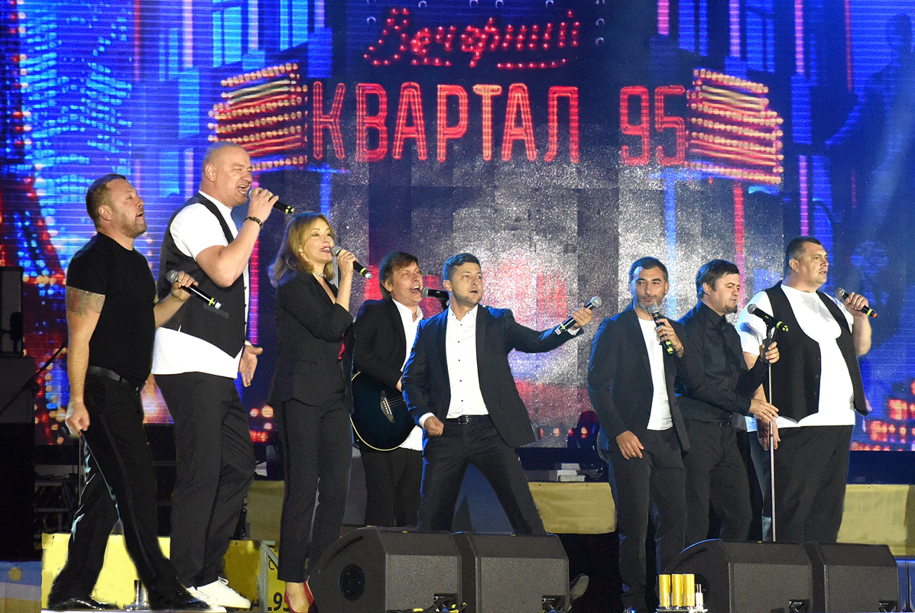

*Source:*[*https://upload.wikimedia.org/wikipedia/commons/thumb/6/63/KVARTAL_95_Vadim_Chuprina.jpg/220px-KVARTAL_95_Vadim_Chuprina.jpg*](https://upload.wikimedia.org/wikipedia/commons/thumb/6/63/KVARTAL_95_Vadim_Chuprina.jpg/220px-KVARTAL_95_Vadim_Chuprina.jpg)

The team's hard work paid off in December 2003, the time when kvartal 95 studio was tagged with “1+1 Studio” on the Ukraine TV Channel. They performed a total of 5 shows and were got famous for their humor in the show. After the success, the team approached Ukraine's top TV channel Inter. The channel only accepted them as they agreed to their condition of using Political humor in the show. The Vechirniy Kvartal, also known as the Evening Quarter, became famous for its political humor during the interwar period. Even though the joke was harsh and can enrage any politicians, they never did stop what they have to convey.

Volodymyr Zelensky got hitched to his childhood companion Olana kiyashko in 2003. She was one of the scriptwriters in his company "Kvartal 95 Studio". A year after their wedding the couple had their first girl Oleksandra. Also, in 2013, they had a son Kyryloto to their Zelensky family.

## What was Popularity like for Volodymyr Zelensky

He became extremely successful as a result of his work, and he began to deliver concerts and live musical presentations, as well as write multiple films and television screenplays. The team has very popular 16 films and series and one of them was nominated for the most popular TV series “The Big Bang Theory”.

### Popular Series and Movies Zelensky Starred in

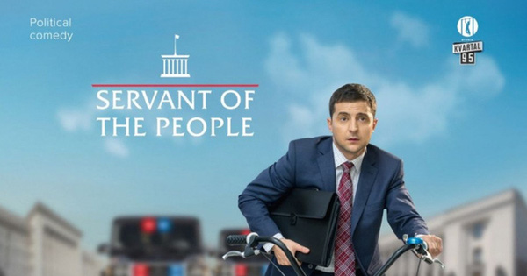

*Source -*[*https://www.newsnpr.org/wp-content/uploads/2022/02/1646029541_Mr-Zelensky-Europes-Most-Vulnerable-President-From-Role-to-Wartime.jpg*](https://www.newsnpr.org/wp-content/uploads/2022/02/1646029541_Mr-Zelensky-Europes-Most-Vulnerable-President-From-Role-to-Wartime.jpg)

* Servant of the People (2015)
* No Love in the City (2009) and Part 2 of No Love in the City (2010)
* 8 First Dates (2012)
* Love in Vegas (2012)
* Our Time (2011)
* Rzhevsky versus Napoleon (2012).
* You. He. She. (2018)

The “Servant of the people” starred Zelensky as a 30-year-old teacher who wins the Presidential election after his student posts a video of him talking about Ukraine's Corruption. This TV Show was screened in 2015 and gained a huge response from the audience and reached 20 million views. Season 2 and season 3 were screened in 2016 and 2019 respectively. The TV Show had affected the audience so much that they started to expect Zelensky to stand for the presidential election in real life too. With all the support and inspiration Zelensky bought himself into politics in 2019.

He won the election and the inauguration took place in Verkhovna Rada of Ukraine on May 20, 2019. Totally 50 Delegates were invited excluding Russia. In his first speech said that “he isn’t gonna hesitate to make tough decisions” and, proved it in the 2022 war with Russia. Even though he struggled in his first year as president to deal with real-life issues, he has grown into an inspiring leader to whom everyone should look up.

## Ukraine-Russia WAR

Russia struck Ukraine at 5 a.m. on February 26th, killing 516 people, including children, and injuring 900 more. It is said that 718 missiles were fired against Ukraine. Zelensky refused when the United States offered to escort him he says “this is war; he needs a weapon, not transport”. He stayed in his workplace and been supporting his people through the war. And, he never stopped fighting in fact he is enhancing his weapons and fought back.

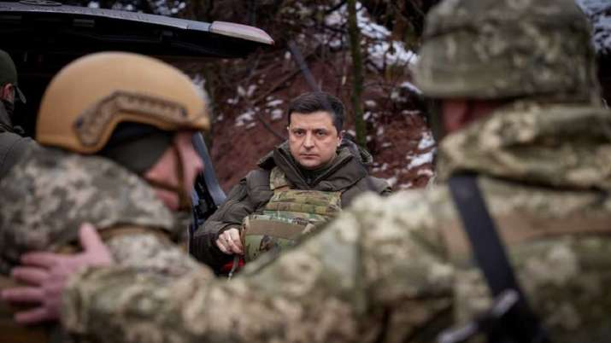

*Source -*[*https://resize.indiatvnews.com/en/resize/newbucket/715_-/2022/02/volodymyr-zelensky-1645769413.jpg*](https://resize.indiatvnews.com/en/resize/newbucket/715_-/2022/02/volodymyr-zelensky-1645769413.jpg)

Many other countries have come to support Ukraine providing them the tools and weapons to win the war. Putin has lost most of the value he had and his mistake or some fault decision to wage war has caused many downfalls for Russia. On the other side, even though there’s a massive attack going on them, Zelensky isn’t giving up on his country and people. Through all his actions Zelensky has gained immense respect. It is not easy for anyone for once to be a fake president in the Series and then became a real president and handle the real-life circumstance, in that case, Zelensky tops it. Ukraine President Volodymyr Zelensky is successful as a Comedian and also a Strong Political Leader. What’s your thought?